Lesson 130
Feature Branch Workflow Demo
Create a new repo in github
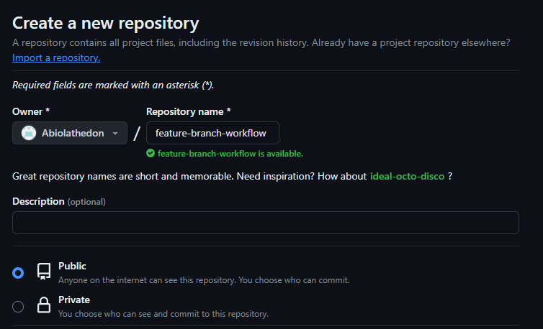
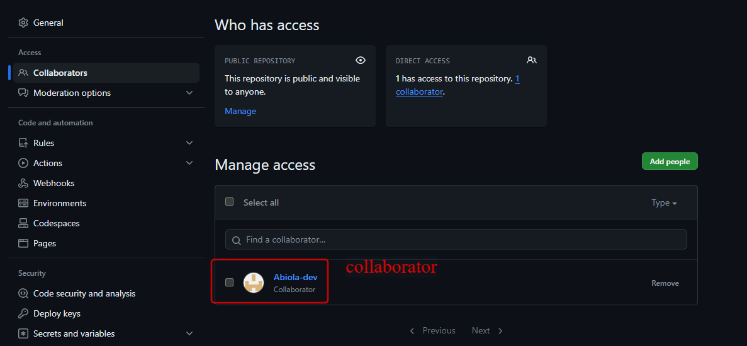
The blue is don while the red is dev
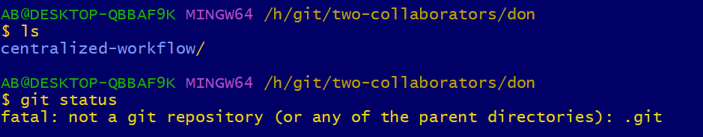
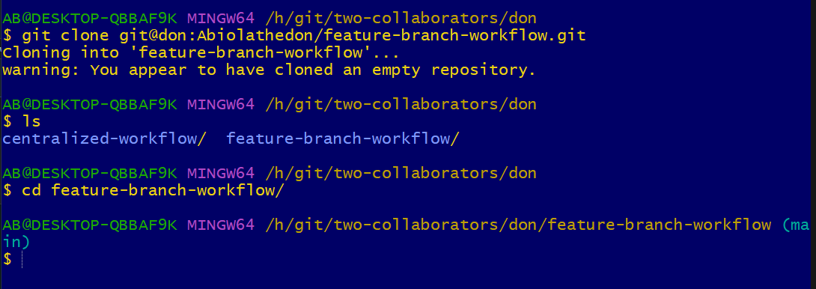
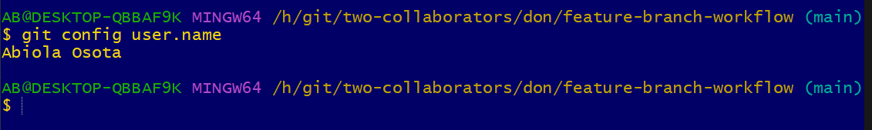
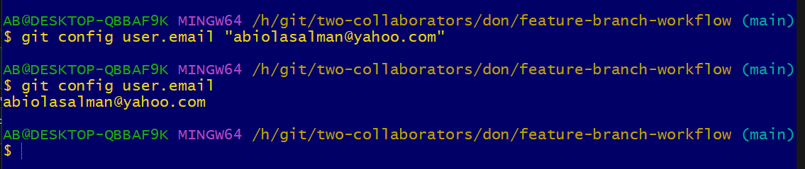
Below is dev
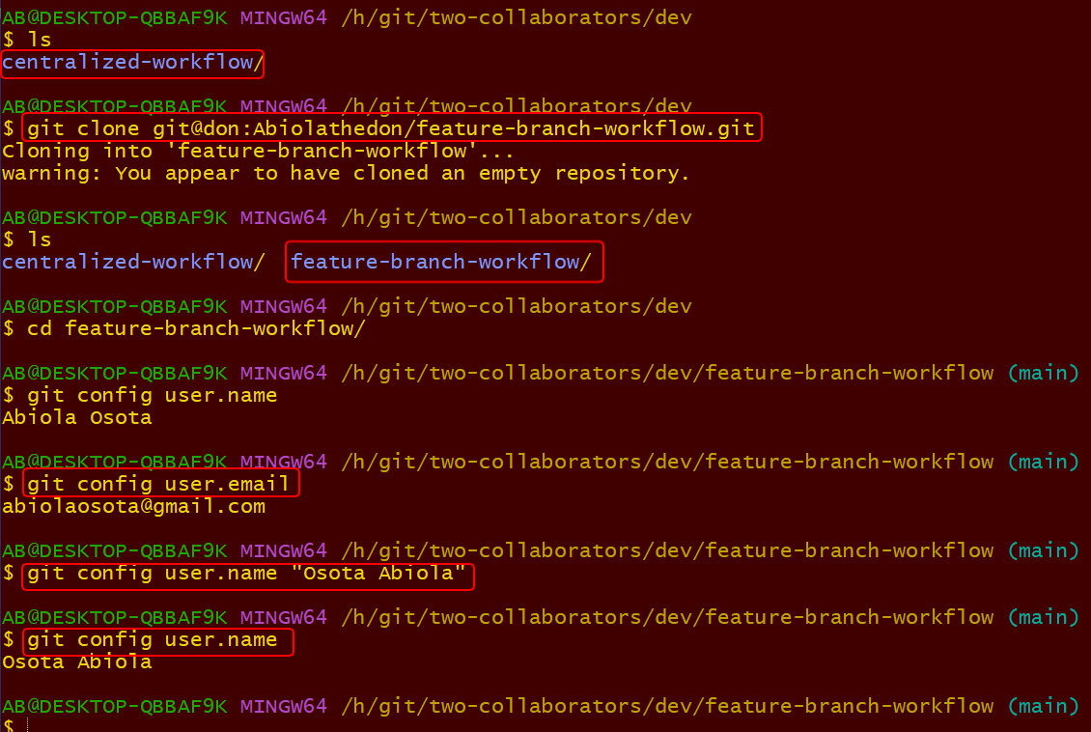
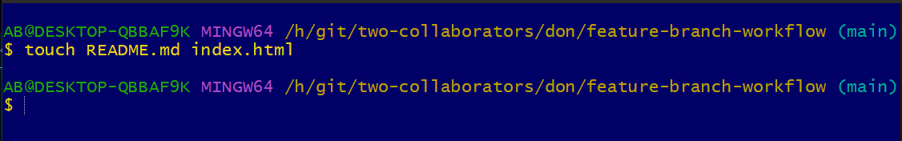
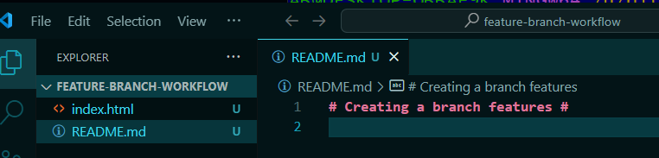
This is dev
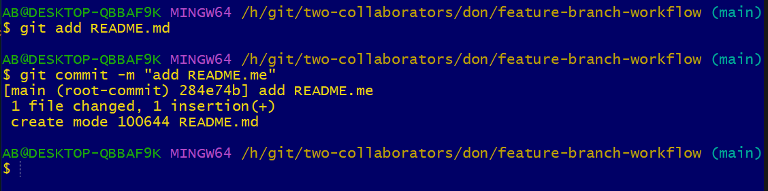
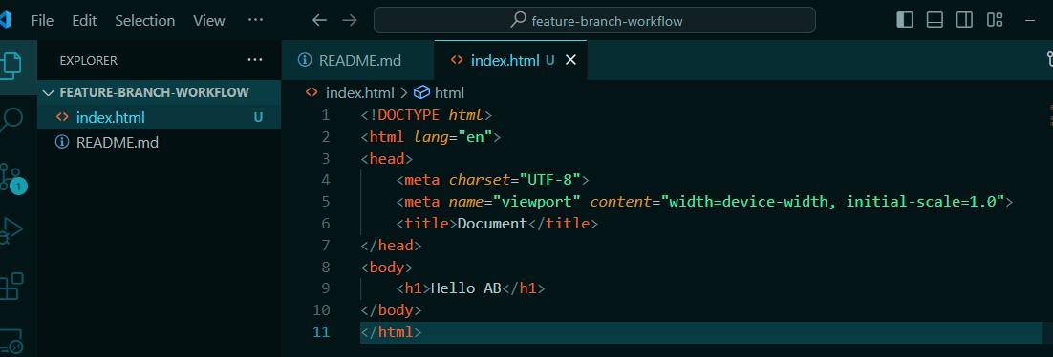
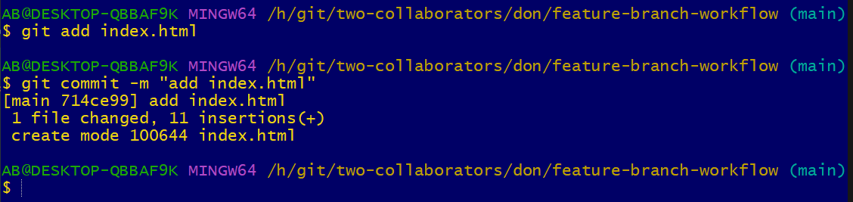
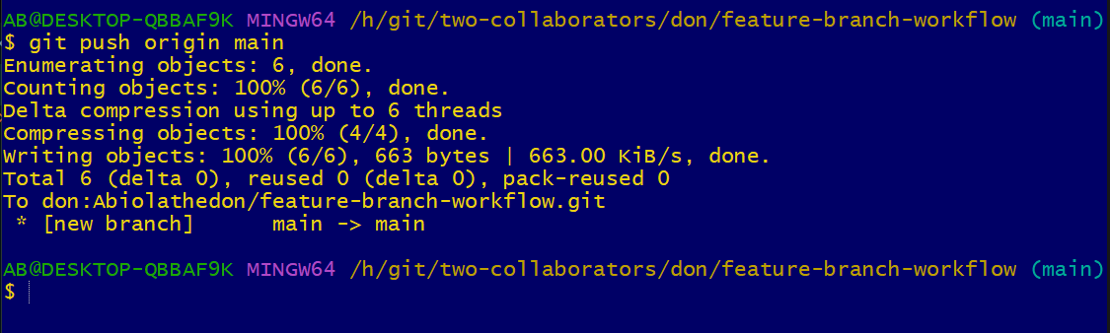
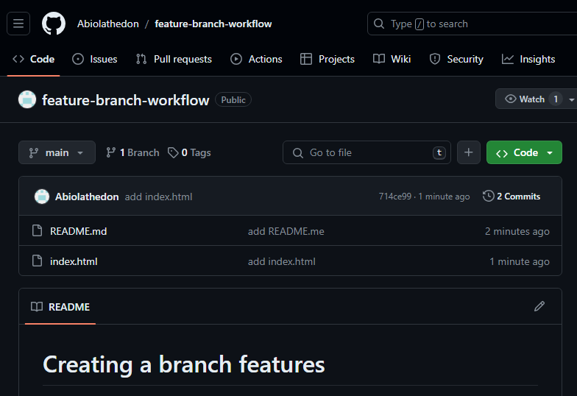
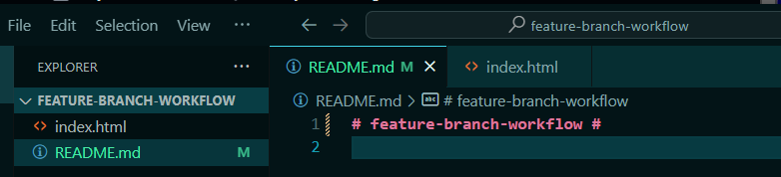
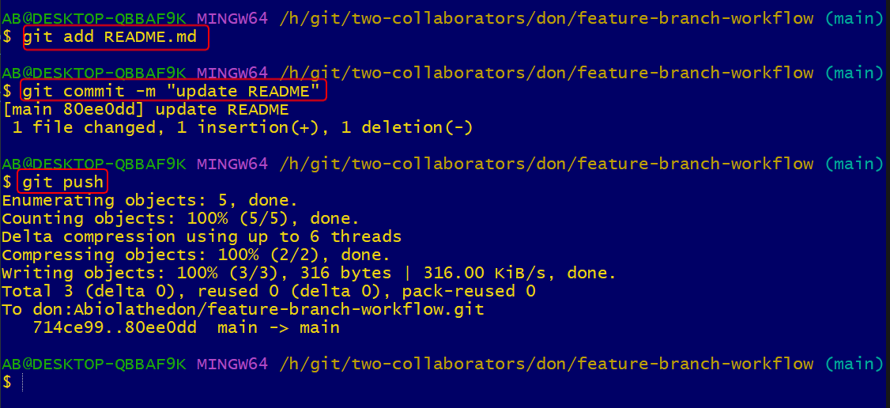
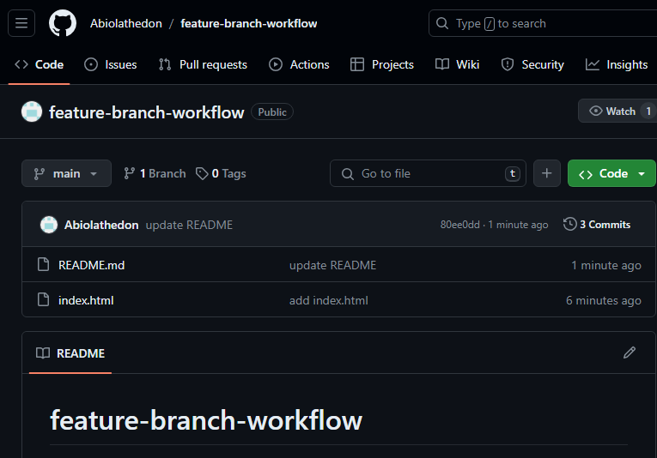
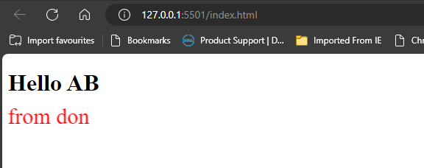
Now I want to work on dev
I made a mistake below I should have just click on pull down from main to get the lastest repo. Not don’t create navbar pull before you pull the changes.
https://getbootstrap.com/docs/4.0/components/navbar/
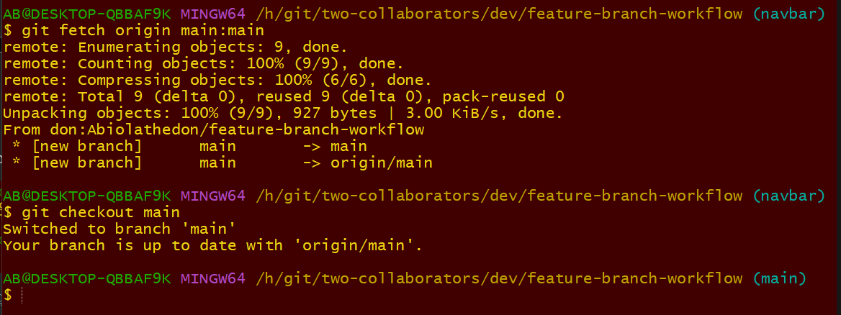
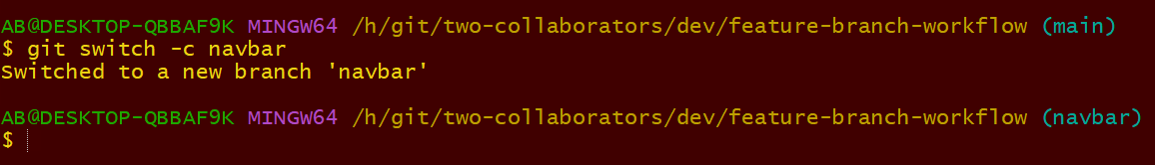
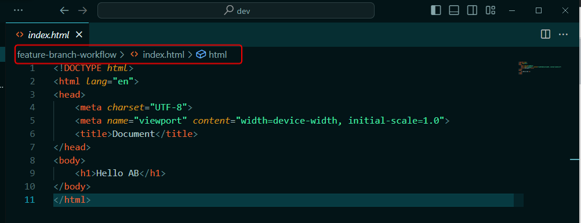
This is what I pulled down. Then I deleted everything
https://getbootstrap.com/docs/5.0/getting-started/introduction/
replaced it with starter template here
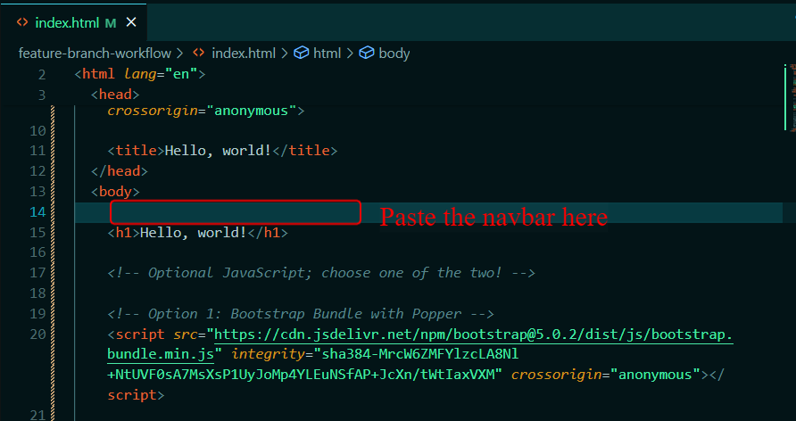
https://getbootstrap.com/docs/4.0/components/navbar/
I copied the navbar and pasted it there.
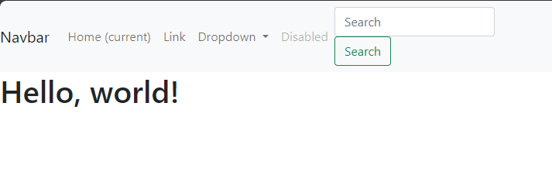
I want to share with don and get advise on what to do.
I will merge into master
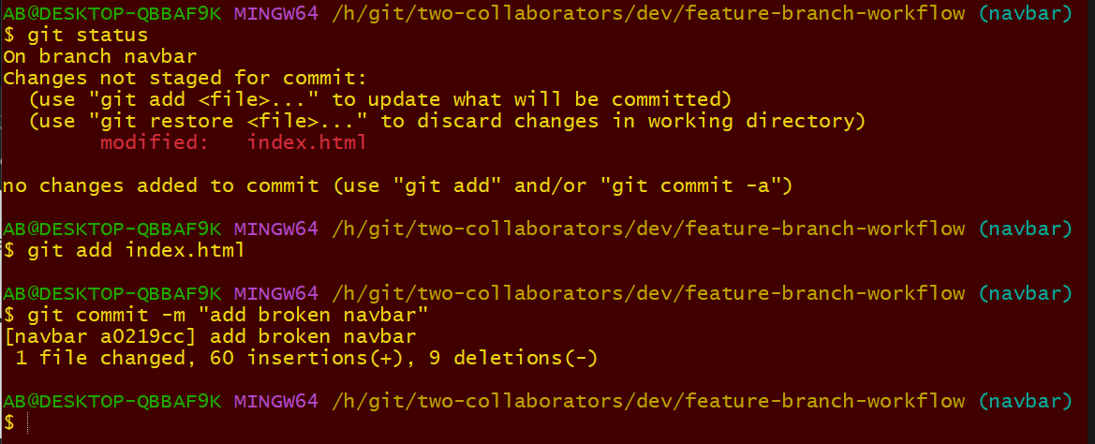
Now I want to push to github for feedback.
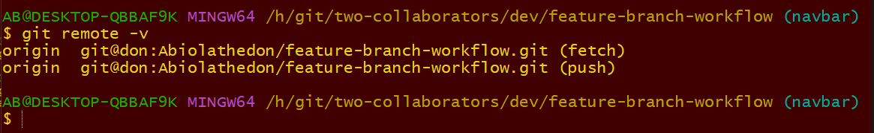
Now I want to push the branch navbar
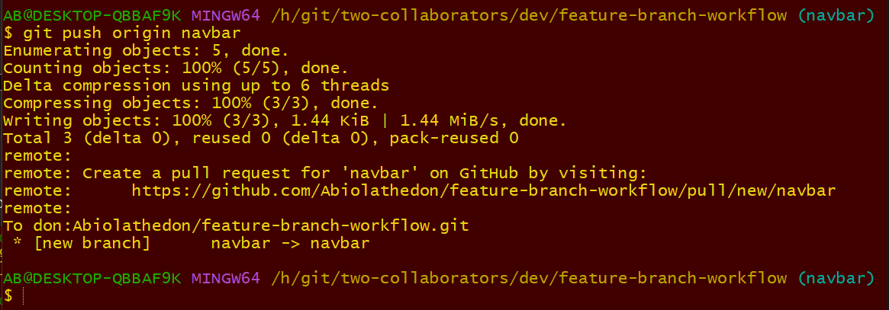
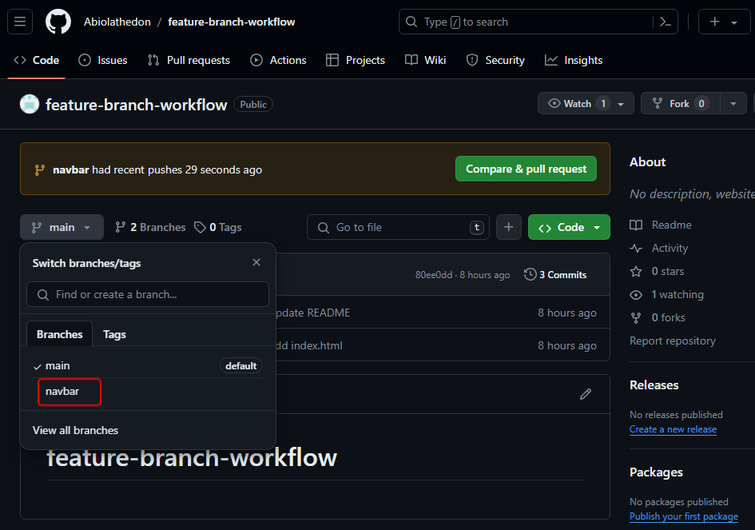
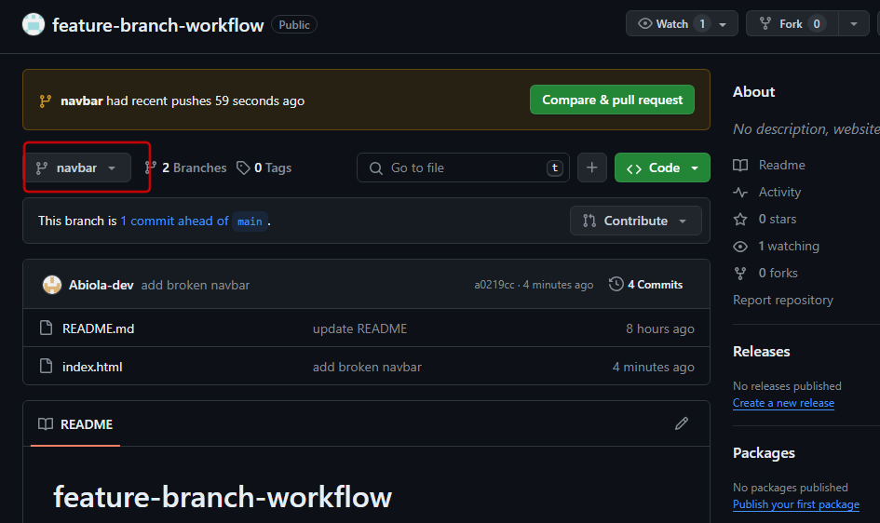
Now I want to go back to don
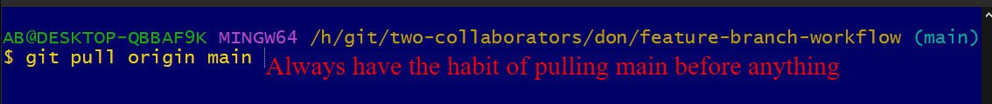
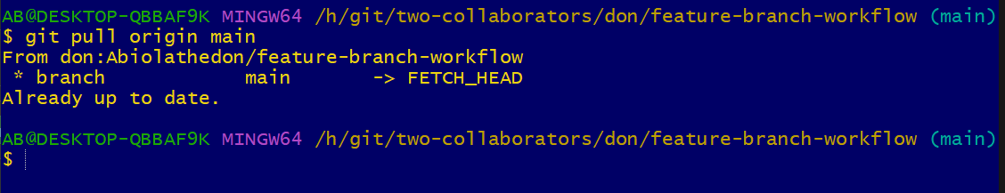
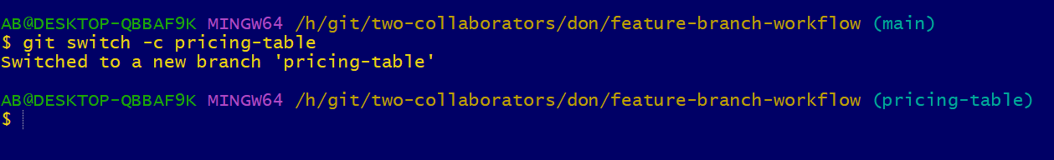
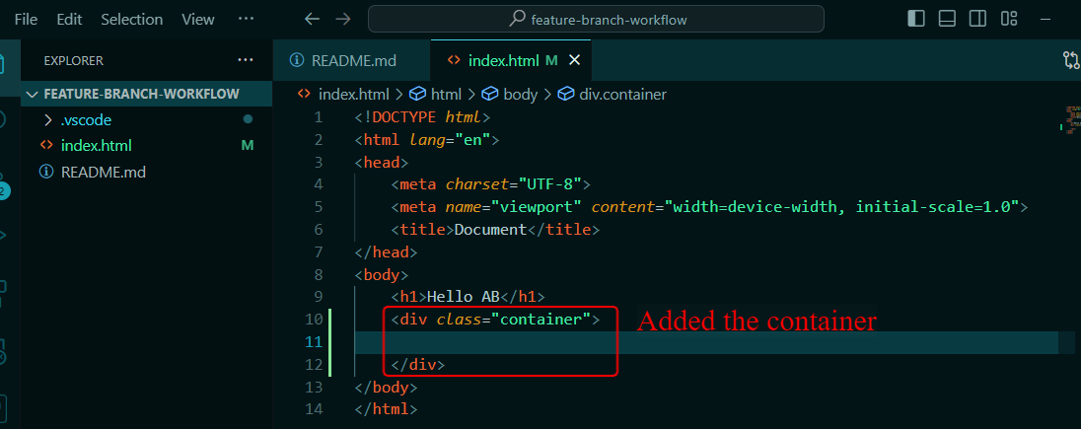
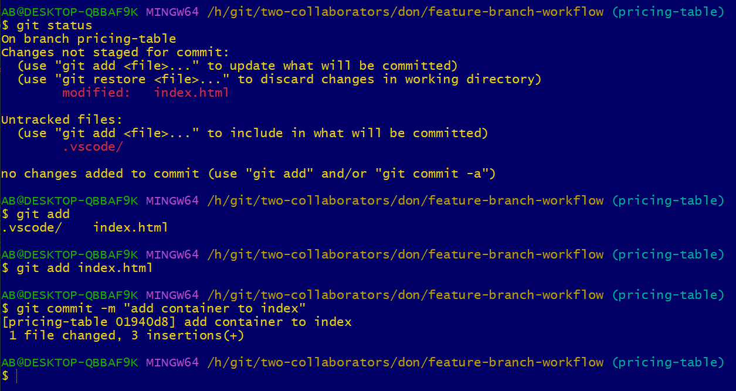
https://getbootstrap.com/docs/5.0/examples/pricing/
<div class="row row-cols-1 row-cols-md-3 mb-3 text-center">
<div class="col">
<div class="card mb-4 rounded-3 shadow-sm">
<div class="card-header py-3">
<h4 class="my-0 fw-normal">Free</h4>
</div>
<div class="card-body">
<h1 class="card-title pricing-card-title">$0<small class="text-muted fw-light">/mo</small></h1>
<ul class="list-unstyled mt-3 mb-4">
<li>10 users included</li>
<li>2 GB of storage</li>
<li>Email support</li>
<li>Help center access</li>
</ul>
<button type="button" class="w-100 btn btn-lg btn-outline-primary">Sign up for free</button>
</div>
</div>
</div>
<div class="col">
<div class="card mb-4 rounded-3 shadow-sm">
<div class="card-header py-3">
<h4 class="my-0 fw-normal">Pro</h4>
</div>
<div class="card-body">
<h1 class="card-title pricing-card-title">$15<small class="text-muted fw-light">/mo</small></h1>
<ul class="list-unstyled mt-3 mb-4">
<li>20 users included</li>
<li>10 GB of storage</li>
<li>Priority email support</li>
<li>Help center access</li>
</ul>
<button type="button" class="w-100 btn btn-lg btn-primary">Get started</button>
</div>
</div>
</div>
<div class="col">
<div class="card mb-4 rounded-3 shadow-sm border-primary">
<div class="card-header py-3 text-white bg-primary border-primary">
<h4 class="my-0 fw-normal">Enterprise</h4>
</div>
<div class="card-body">
<h1 class="card-title pricing-card-title">$29<small class="text-muted fw-light">/mo</small></h1>
<ul class="list-unstyled mt-3 mb-4">
<li>30 users included</li>
<li>15 GB of storage</li>
<li>Phone and email support</li>
<li>Help center access</li>
</ul>
<button type="button" class="w-100 btn btn-lg btn-primary">Contact us</button>
</div>
</div>
</div>
</div>
I put it inside the div
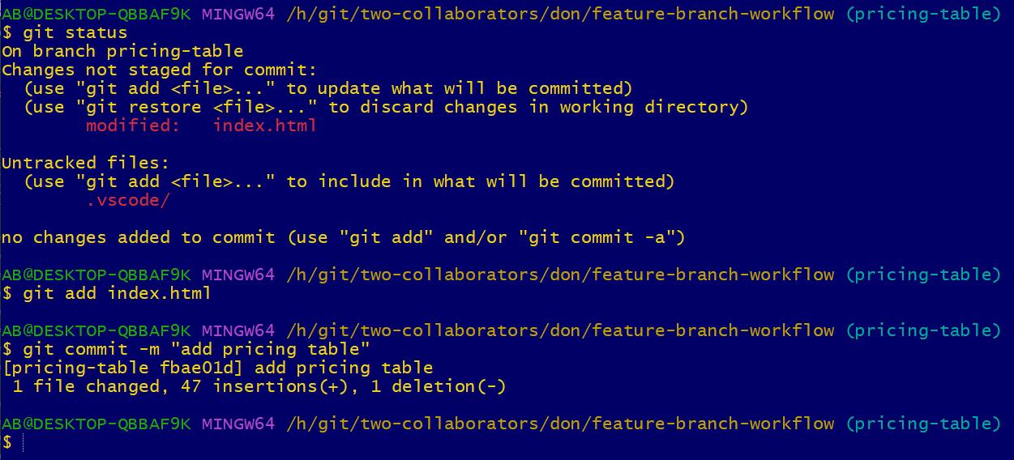
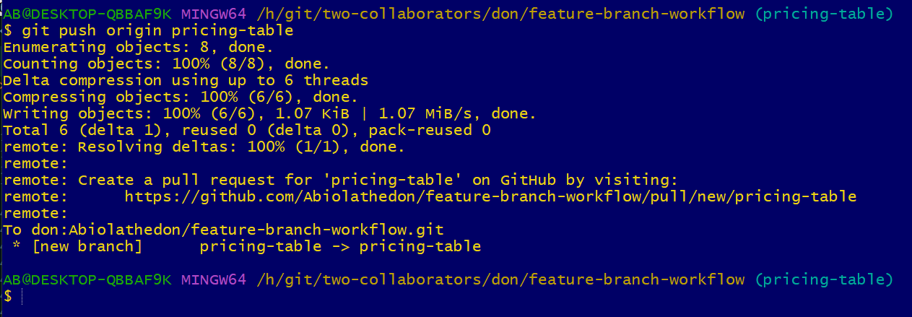
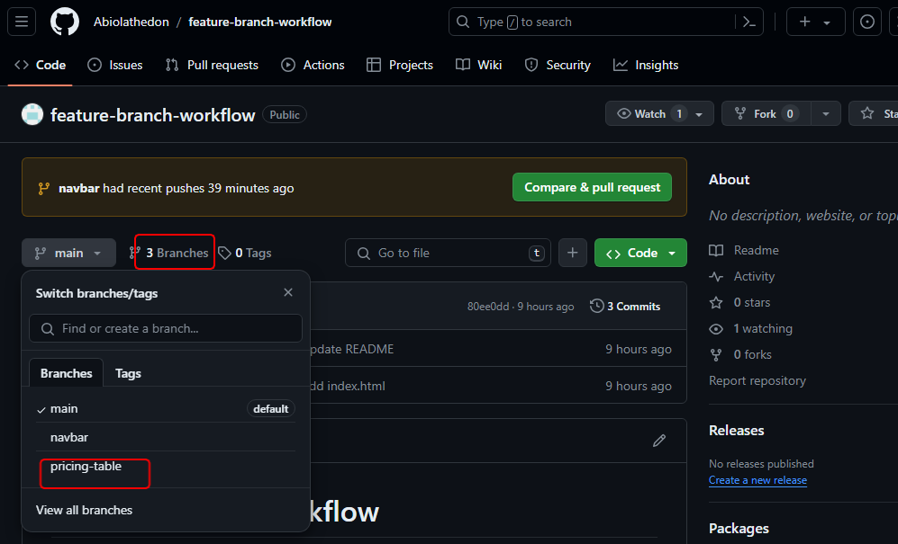
Dev team complained about the nav branch not working don will pull down the nav branch and work on it.
Always have the habit of pull before you do anything
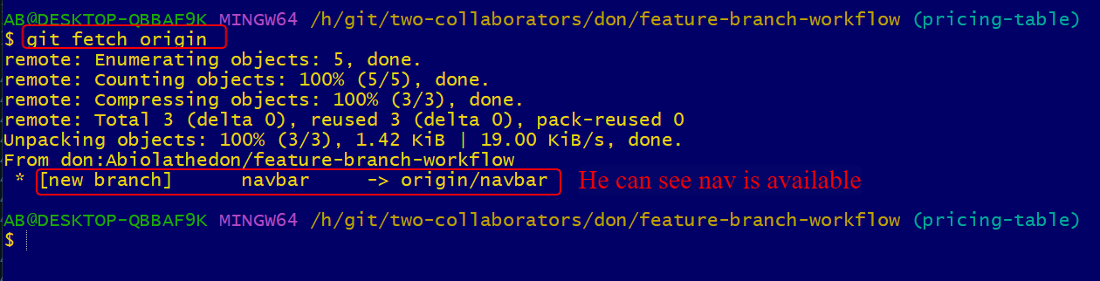
Ramadan Saturday 06/04/2024
Now I want to go to detached head
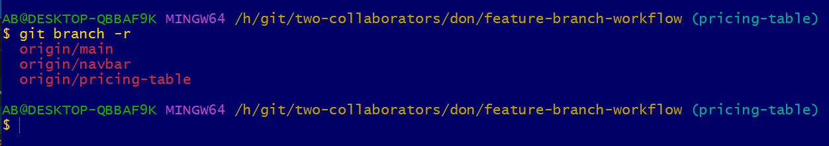
This are remote tracking.
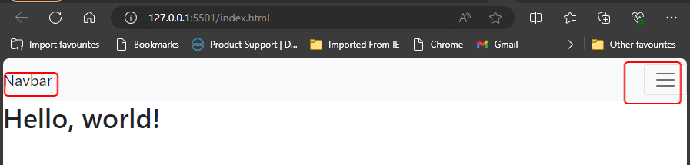
This is to check. The nav bar is not working properly I need to leave the detach head now
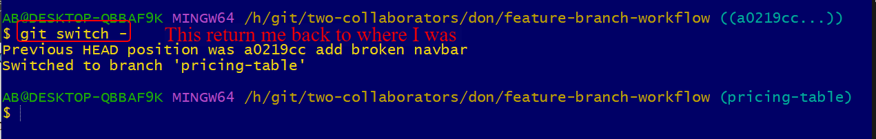
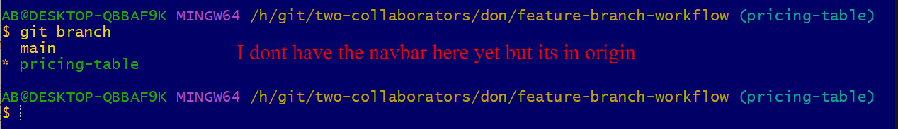
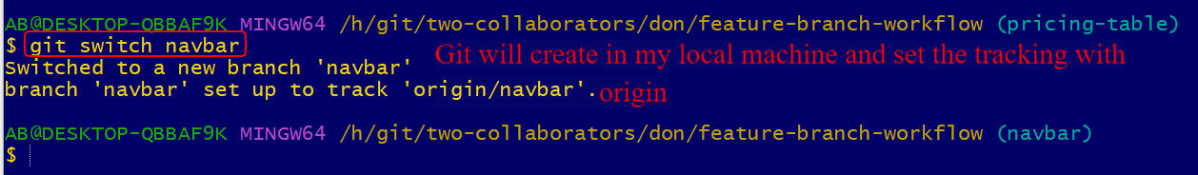
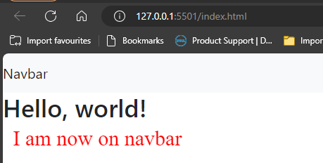
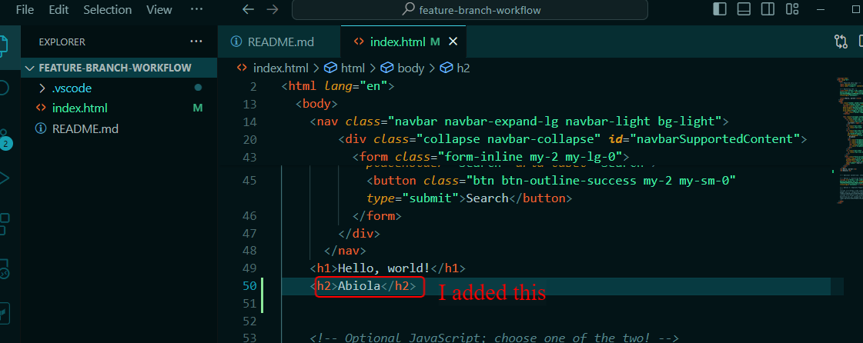
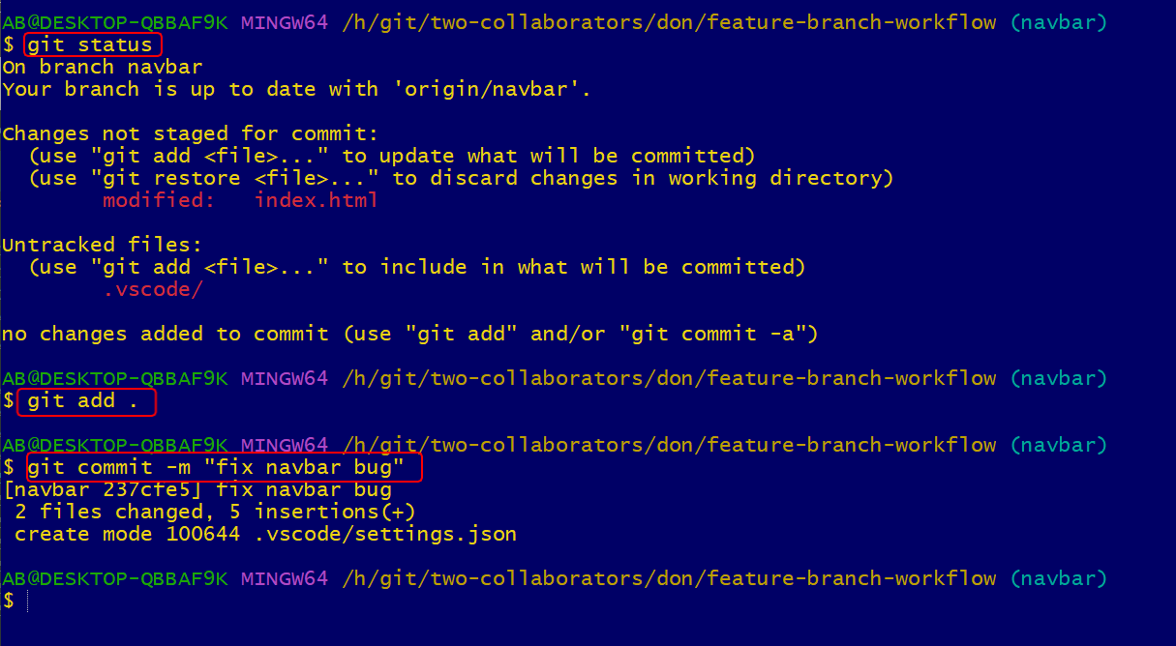
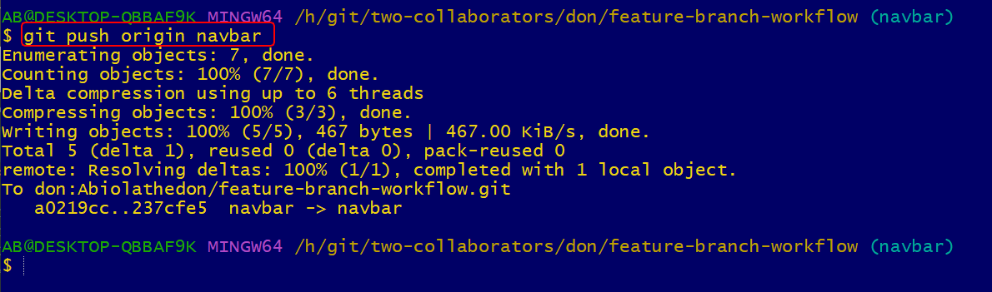
I have pushed it now
I can go back to pricing table
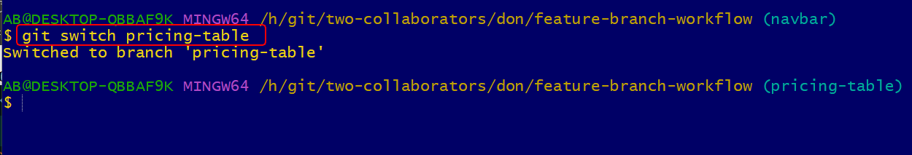
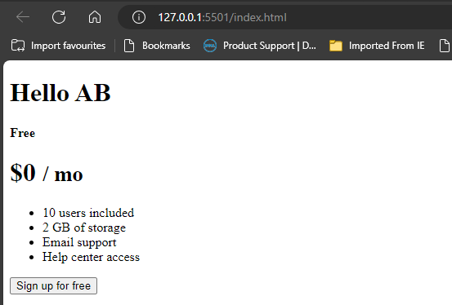
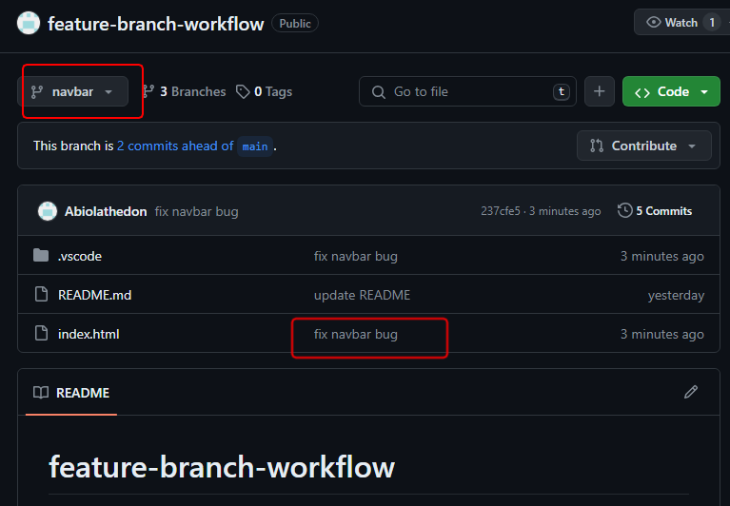
Now go to Dev
I will need to pull the navbar down to see the changes
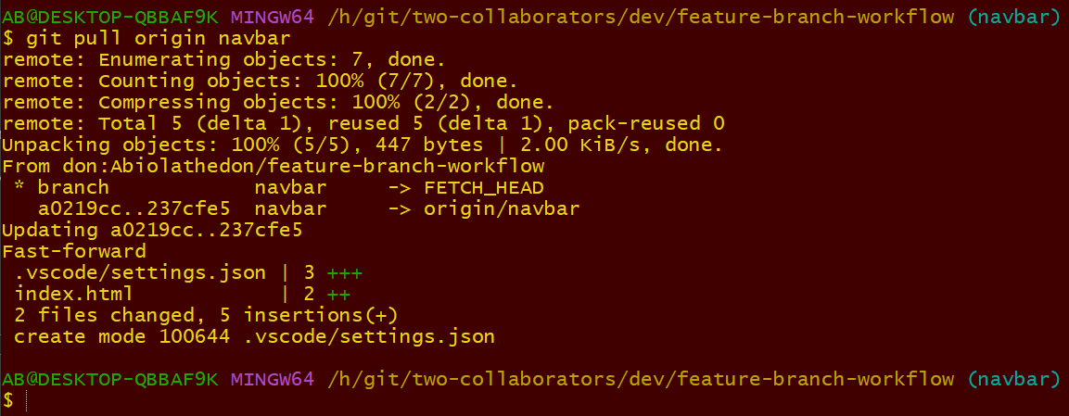
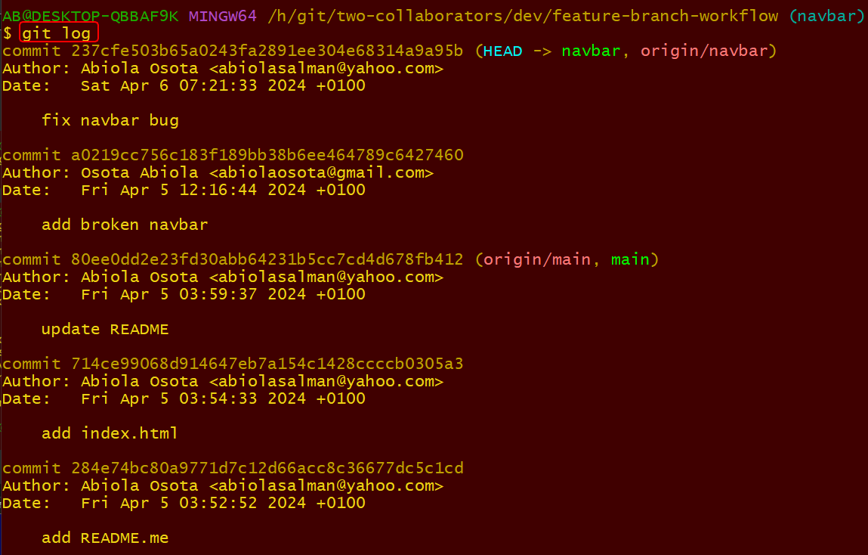
Its working now I just don’t show the vscode.

